Removing a Lock: Application Lock Manager

Go to: Sys Admin>Utilities>Application Lock Manager
You will see a screen that looks like the following:
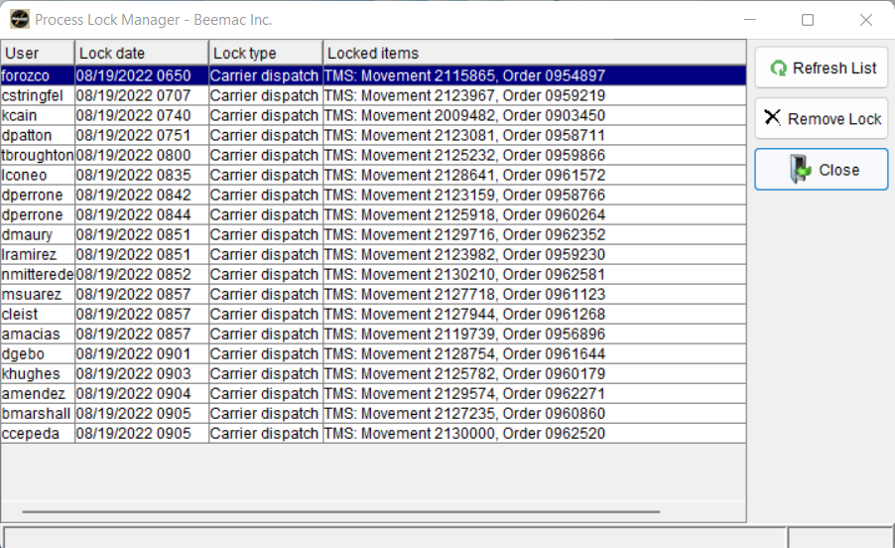

To remove the lock, highlight the locked order and select “Remove Lock” on the right-hand side

