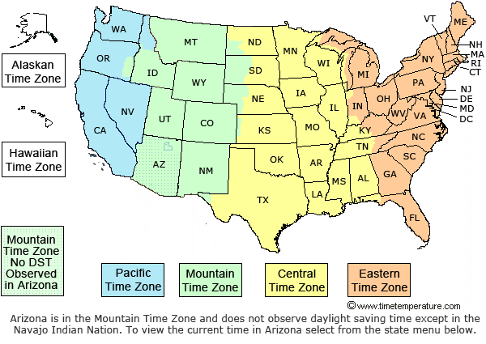

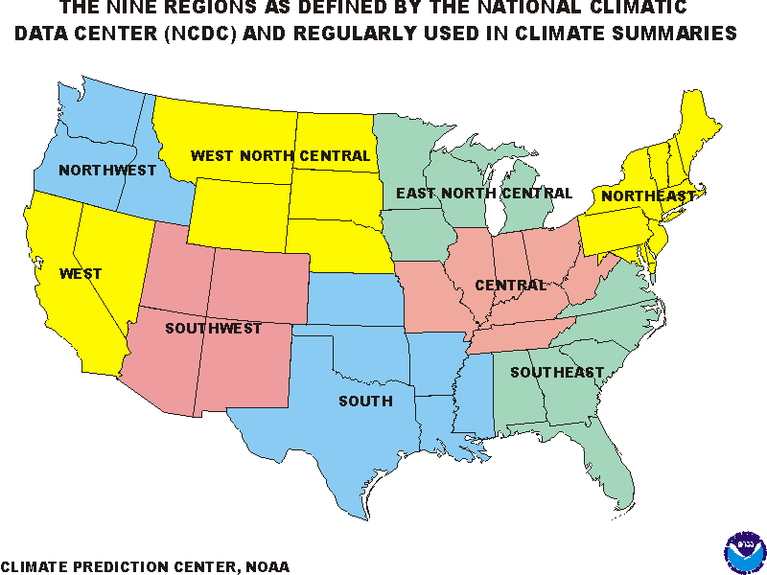

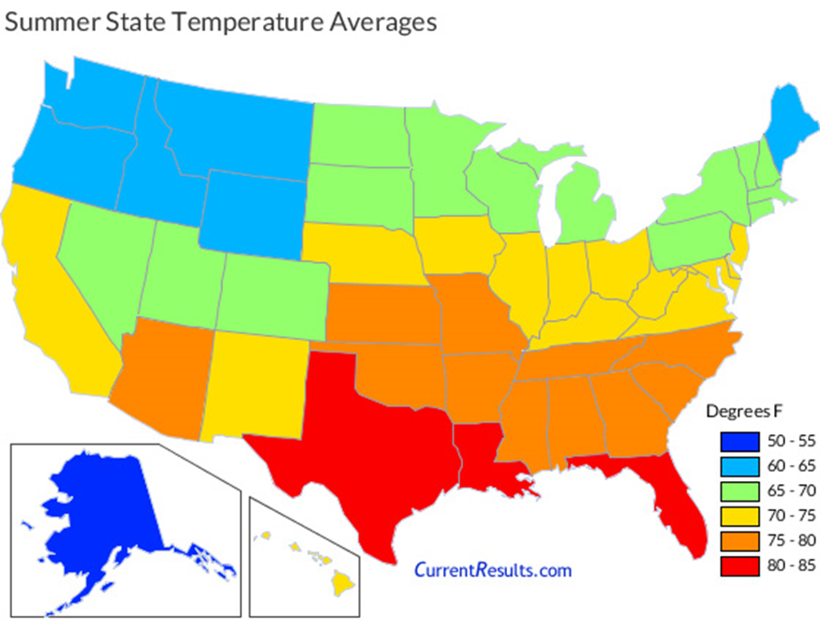

**The Meteorological Seasons**  
  
Meteorological spring in the Northern Hemisphere includes March, April, and May; meteorological summer includes **June**, **July**, and **August**; meteorological fall includes September, October, and November; and meteorological winter includes **December**, **January**, and **February**

**Major Weather culprits for the Trucking Industry**

**Snow and Ice**

Accounting for more than 50% of all weather-related traffic delays, snow and ice have a big impact on mobility and visibility for truckers and others on the road.

meteorological winter includes **December**, **January**, and **February.**

**Rain**

Heavy rains are another huge obstacle to visibility, cutting a trucker’s speed down by 25%. In fact, 46% of wrecks take place during periods of heavy rain.

Typically, **monsoon season** is the **months** of July, August, and September. That's when afternoon thunderstorms are most frequent and severe.

**High Winds**

A big issue in the western states, high winds can create a variety of hazards for truckers, including harmful debris blowing into the road. Additionally, high winds can impact the stability of trucks, resulting in speed reductions and even accidents.

**Natural Disasters**

As covered in the recap of 2020’s significant weather events, natural disasters, like hurricanes, blizzards, tornadoes, and floods, shut down roads, leaving goods to be stranded for days. These delays can result in up to a $100 million a day in losses.

In the Northern Atlantic Ocean, September is the most active - a distinct **hurricane** season occurs from June 1 to November 30, sharply peaking from late August through September.

**Tornadoes** can form at any time of year, but most occur in the spring and summer months along with thunderstorms. May and June are usually the **peak** months for tornadoes.

**Extreme Heat**

Finally, extreme temperatures can also cause delays for a trucker and potential issues in cargo quality. Driver capability, vehicle performance, pavement friction, roadway infrastructure, and traffic flow can all be negatively impacted by high heat.

In dealing with all of these kinds of weather, safety for the drivers and others on the road should be trucking companies and shippers’ highest priority. This includes supporting trucking companies and truckers in proper safety standards as well as weather and emergency preparedness.

For most of the country, the **warmest** day occurs sometime between mid-July and mid-August.

**5 WAYS WEATHER AFFECTS YOUR FREIGHT SHIPMENT –June 25, 2020 by Constantinos Garoufalidis**

**1. Capacity Limitations**

When a natural disaster or other forms of inclement weather impact trucks on the road, that means there are less trucks available to conduct normal operations. A traffic jam on a major highway due to too much snow or flooding or a driver having to take a different route’ than expected keeps trucks and truckers out of the capacity pool. So, a storm across the country that may not have directly impacted the customer could have some kind of influence over their carrier options and rates.

**2. Power Outages**

If the power goes out, the freight world can’t do much. Hurricanes, tornadoes, severe blizzards, and other forms of extreme natural disasters damage infrastructure, power lines, communication channels, and more. That makes it difficult to do things that are vital during the freight shipping process like getting updates and statuses on your freight. Additionally, truckers can’t fill up at gas stations in an impacted area, and it becomes a big mess. We have access to powerful transportation management software that can help you track your shipment. Additionally, we keep track of inclement weather for our customers, keeping them in the loop no matter the circumstances.

**3. Guarantees and Expedited Shipping**

Opting for guaranteed or expedited shipping services is an additional cost which puts your shipment at the top of carriers’ priority lists. But, when unexpected, dangerous weather comes along and disrupts the timing of your shipment’s transit, nothing is guaranteed anymore. Remaining cognizant of weather conditions along the route your shipment is taking helps you manage your expectations in terms of estimated transit times.

**4. Terminals**

Much like roads that may be closed temporarily or are open with limited capacity due to abnormal weather, freight terminals are no different. Terminals may either close completely or conduct limited operations. This isn’t just for the safety of the facility itself, but for the people who are working in that terminal keeping it operational. Safety is top priority for everyone involved. If the terminal has limited access during bad weather, it means that some shipments will go out, but shipments could be delayed. Terminal closures occur when it’s too dangerous for anyone to be working at the freight terminal or to be driving on the roads.

**5. Road Conditions**

If flooding or too much snow accumulates on the road, road closures could happen. That means an alternative route needs to be taken, which could possibly extend transit time. As frustrating as that is for all parties involved, safety is the top priority when it comes to truckers on the road. Keeping truckers safe also means that your freight shipment is kept safe, even though hazardous road conditions might delay delivery times. Hauling an 18-wheeler weighing 4 tons while carrying thousands of dollars of products in the trailer can be stressful in itself. When you add in poor visibility, traction issues, braking quickly, and other drivers on a dangerous road, the drivability of freight trucks gets trickier.